0.65 Acres
Covington, GA
Newton County
$500,000.00

Property Features:

155 ft of frontage on Hwy 278
- 217 ft of frontage on Hannah St
(access property from Hannah St)

All Utilities

Zoning:

- Commercial/CM*

*CM = Corridor Mixed Use

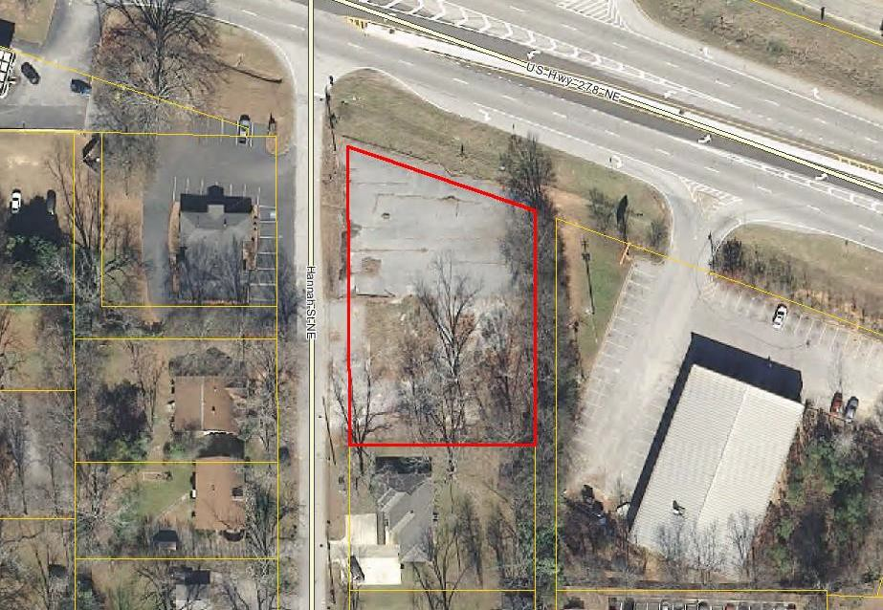

Directions:

From ATL
- I-20 East to Exit 93 (Hwy 142) – Turn RIGHT
  - Take Hwy 142 to Hwy 278 – Turn RIGHT
- Take Hwy 278 for 0.5 mi – Turn LEFT on to Hannah St
  - Property is on the corner of Hwy 278 & Hannah St

Contact:

David Hays

The Mansfield Group 770.787.5400
dawgs74hays@yahoo.com

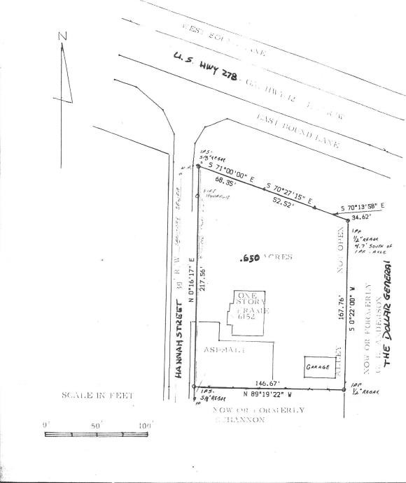
SURVEY

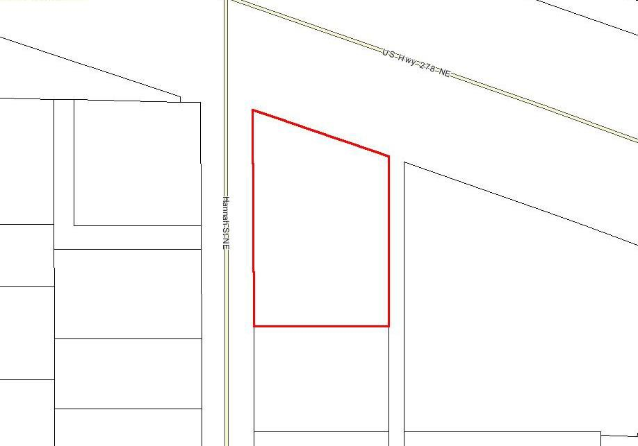
AERIAL

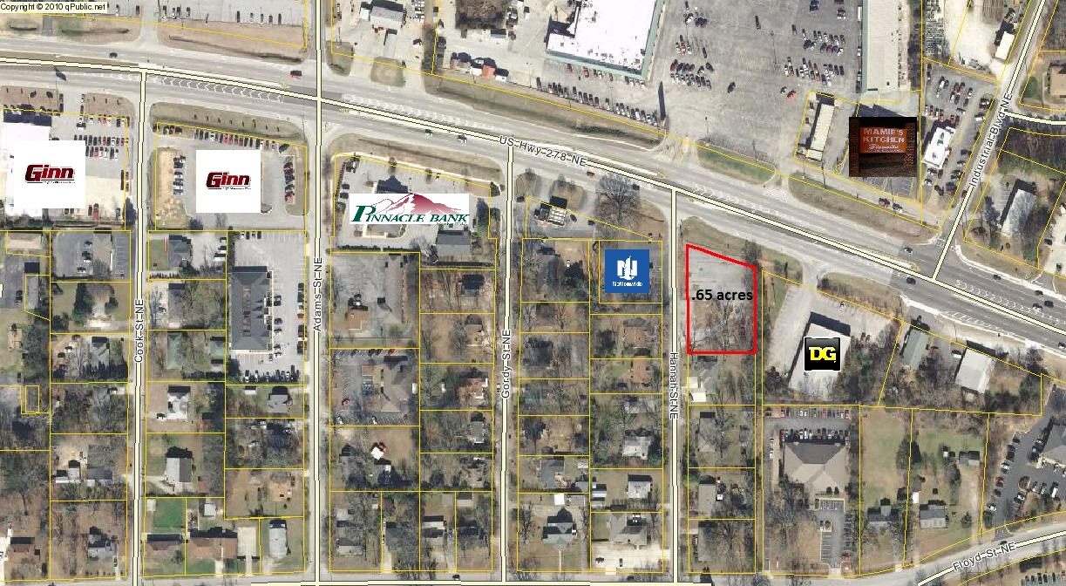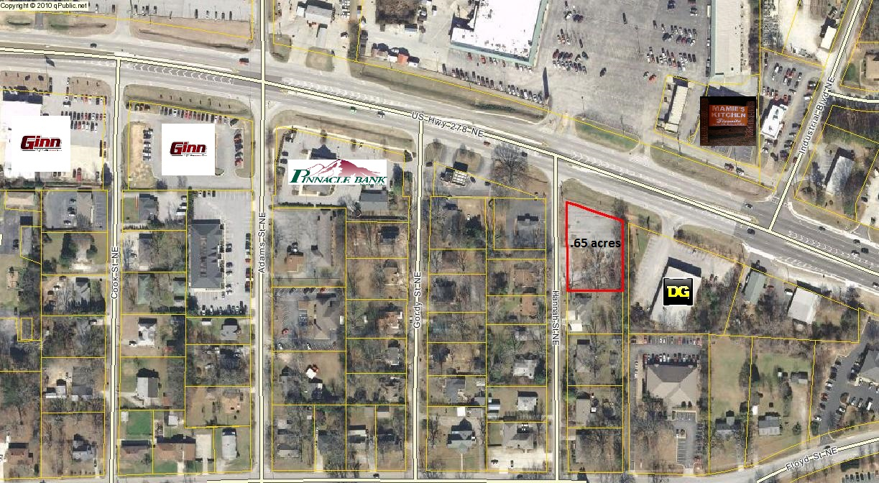

0.65 ac

.65 ac

0.65 ac

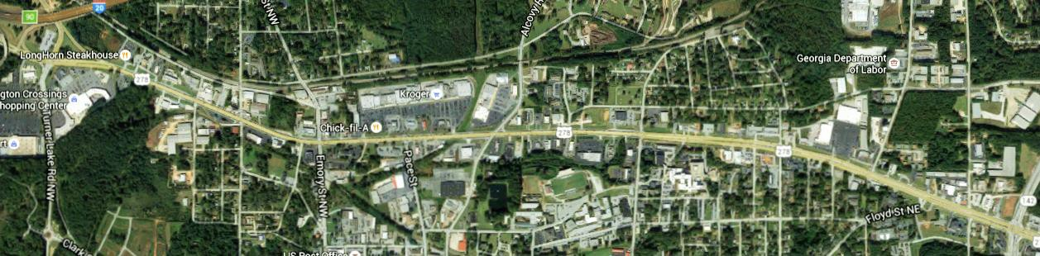
MAPS

Hwy 278 Business Corridor

SITE

Contact Information

For more information, please
Contact BROKER:

David Hays
770.787.5400

dawgs74hays@yahoo.com

The Mansfield Group
1108 Monticello St.
Covington, GA 30014

