|  |
| --- |
| Dearing Crossing |
| 20+/- Acres  (will divide) |

*Contact Broker for Price*

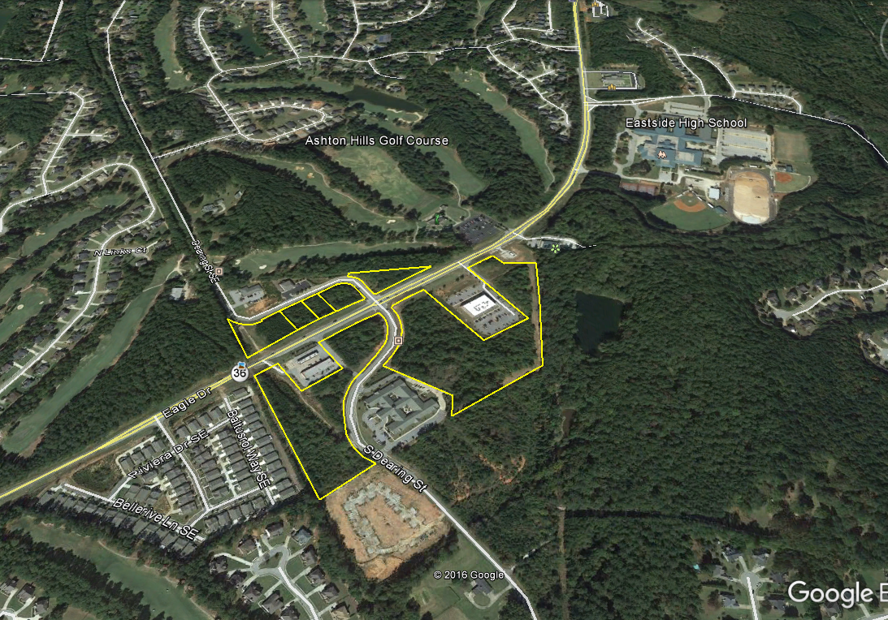

- Zoned PUD Commercial

- All utilities included

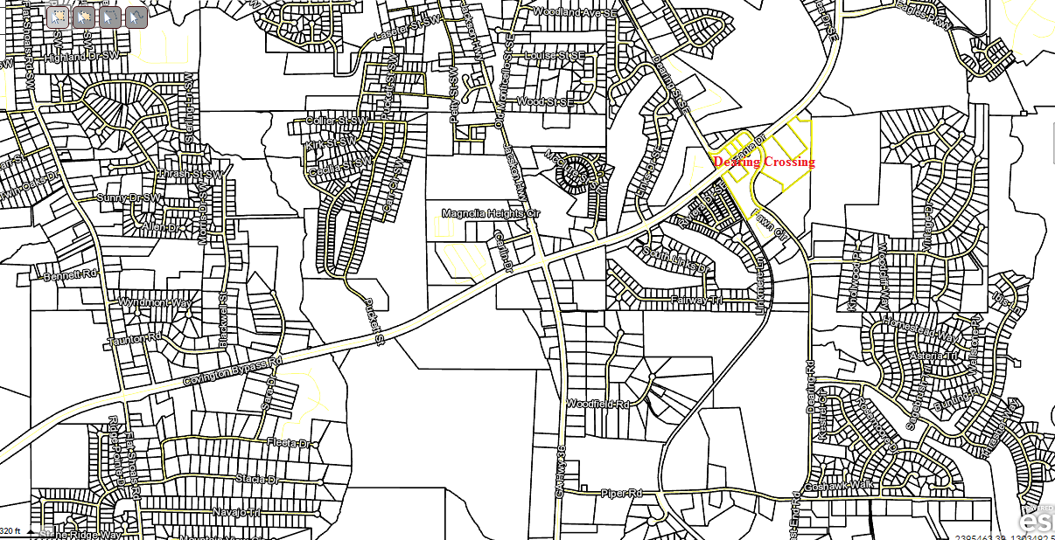

**View with I20**

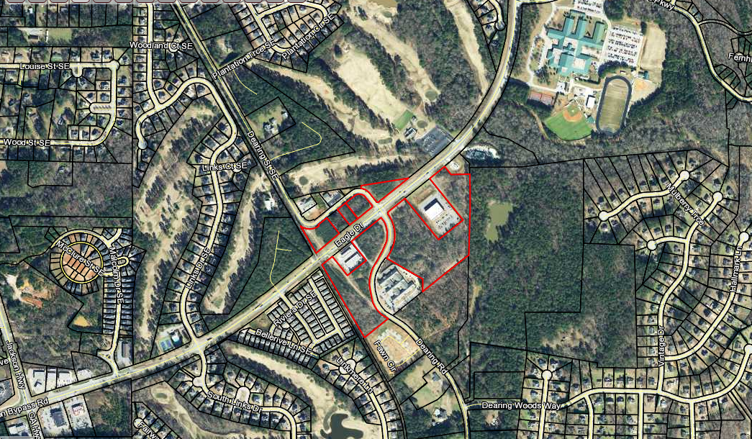

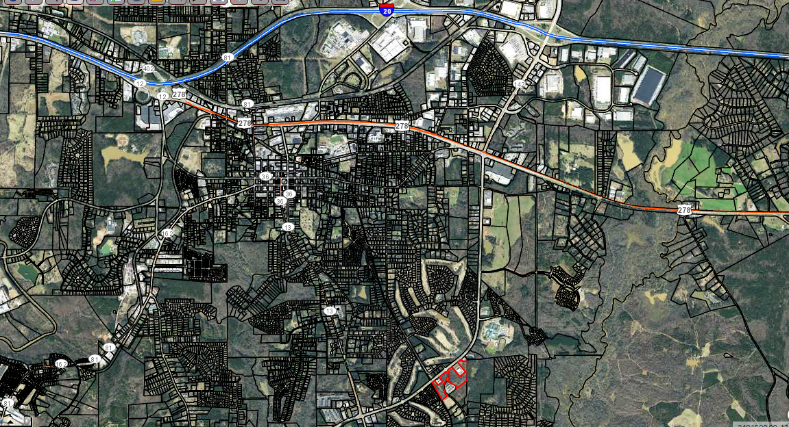

Contact:

David Hays

The Mansfield Group

770.787.5400

[Dawgs74hays@yahoo.com](mailto:Dawgs74hays@yahoo.com)



.